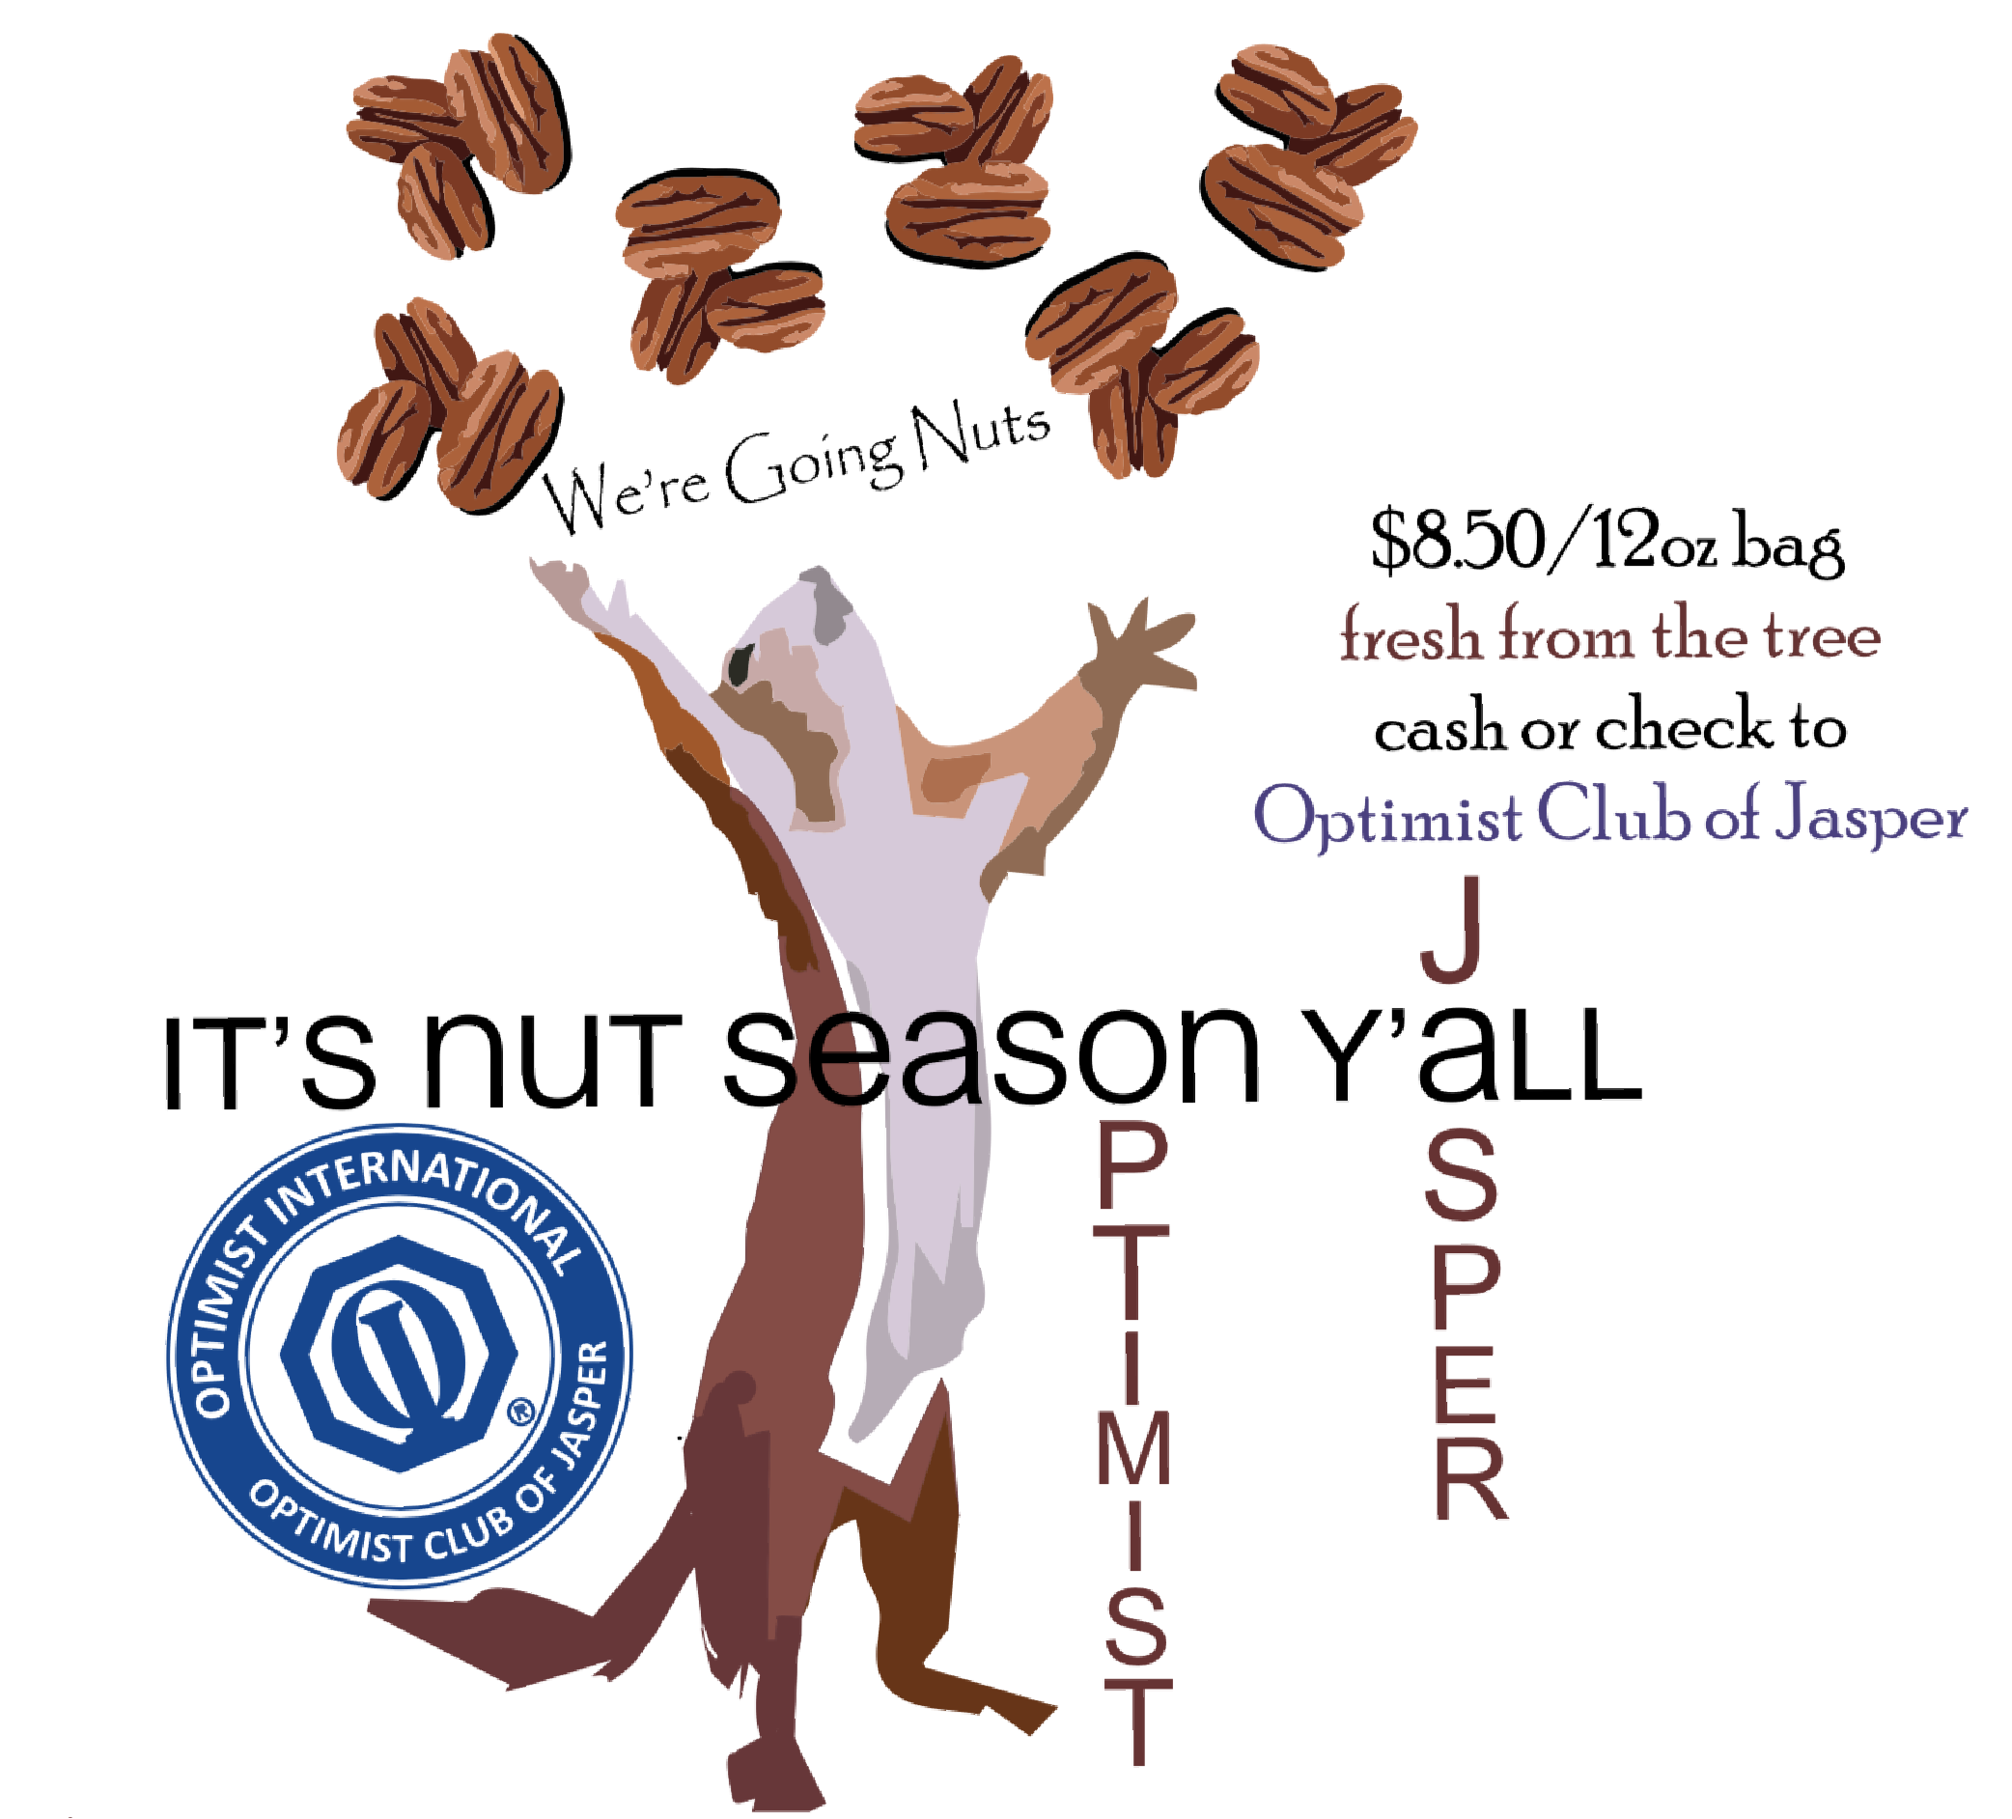
U
CLUB
$11.00 per bag
Available from these fine partners while supplies last!
Garner Ace Hardware
Ace Hardware at Foothills
United Community Bank
Community Bank of Pickens County
Renasant Bank
Parish Lowrie State Farm

